**Brooklyn torah gazette**

**For parshas vayeitzei 5781**

Volume 5, Issue 11 (Whole Number 211) 12 Kislev 5781/ November 28, 2020

**Printed L’illuy nishmas Nechama bas R’ Noach, a”h**

This means, if one doesn't provide food to those who need it, he is held responsible for everything wrong that happens due to this error.

**Free at Last:**

**Jonathan Pollard is a Free Man as Parole Ends**

**By D. Stein**

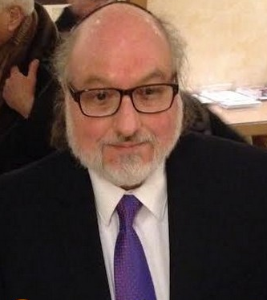

Free at last.

After 30 years in prison and five years on rigid parole conditions, Jonathan Pollard became a free man today, Erev Shabbos.

Pollard’s attorney stated, “The U.S. Parole Commission has issued a certificate terminating parole and lifting all parole restrictions on our pro bono client Jonathan J. Pollard. Specifically, Mr. Pollard is no longer subject to a curfew, is no longer prohibited from working for a company that does not have U.S. government monitoring software on its computer systems, is no longer required to wear a wrist monitor that tracks his whereabouts, and is free to travel anywhere, including Israel, for temporary or permanent residence, as he wishes.”

His lawyer added, “We are grateful and delighted that our client is finally free of any restrictions, and is now a free man in all respects,” the statement said. “We look forward to seeing our client in Israel.”

**A Former Intelligence Analyst for the United States Government**

Pollard is a former intelligence analyst for the United States government. In 1987, as part of a plea agreement, Pollard pleaded guilty to spying for and providing top-secret classified information to Israel. He was sentenced to life in prison for violations of the Espionage Act.

Pollard is the only American who has received a life sentence for passing classified information to an ally of the U.S. In defense of his actions, Pollard declared that he committed espionage only because “the American intelligence establishment collectively endangered Israel’s security by withholding crucial information”.

Israeli officials, U.S.-Israeli activist groups, and some U.S. politicians who saw his punishment as unfair lobbied continually for reduction or commutation of his sentence. The Israeli government acknowledged a portion of its role in Pollard’s espionage in 1987, and issued a formal apology to the U.S., but did not admit to paying him until 1998. Over the course of his imprisonment, Israel made repeated unsuccessful attempts through both official and unofficial channels to secure his release. He was granted Israeli citizenship in 1995.

Opposing any form of clemency were many active and retired U.S. officials, including Donald Rumsfeld, Dick Cheney, former CIA director George Tenet; several former U.S. Secretaries of Defense; a bi-partisan group of U.S. congressional leaders; and members of the U.S. intelligence community.

**Claims that Pollard’s Espionage was Far More Severe**

They maintained that the damage to U.S. national security due to Pollard’s espionage was far more severe, wide-ranging, and enduring than publicly acknowledged. Though Pollard argued that he only supplied Israel with information critical to its security, opponents pointed out that he had no way of knowing what the Israelis had received through legitimate exchanges, and that much of the data he compromised had nothing to do with Israeli security.

Pollard revealed aspects of the U.S. intelligence gathering process, its “sources and methods”. He sold numerous closely guarded state secrets, including the National Security Agency’s ten-volume manual on how the U.S. gathers its signal intelligence, and disclosed the names of thousands of people who had cooperated with U.S. intelligence agencies.

While Bibi Netanyahu argued that Pollard worked exclusively for Israel, Pollard admitted shopping his services—successfully, in some cases—to other countries.

Some of the accusations against Pollard can be traced to a CIA mole named Aldrich Ames, who allegedly caused a shift to “blame Mr. Pollard for exposing the American agents to clear himself of suspicion.” The same source “said that Mr. Pollard never exposed American agents in the Soviet Union or elsewhere.”

Pollard was released today in accordance with federal guidelines in place at the time of his sentencing.

*Reprinted from the November 20, 2020 website of Matzav.com*

**What Makes A**

**Rabbi Orthodox?**

**By** [**Rabbi Chananya Weissman**](https://www.jewishpress.com/author/chananyaweissman/)



*Editor’s note: This op-ed was written in response to an October 29 news story by the JTA on several rabbis with Orthodox semicha who officiate (or are willing to officiate) at same-gender weddings.*

Ever since Jews were allowed out of the ghettos, the debate has raged on how to approach the outside world. Many have chosen to barricade themselves from it as much as possible, while others have chosen to embrace it and separate the good from the bad.

I’m not here to decide between the two, and I truly believe elements of both approaches should be adopted by everyone. But while both approaches are legitimate, we must also acknowledge that both have serious vulnerabilities.

For example, it is all too easy for those who embrace the outside world to embrace its values as well. Even rabbis are susceptible to this temptation. Indeed, those with the most brilliant minds are *especially* susceptible to the *yetzer hara* to reconcile that which is foreign – even that which is abhorrent – with the Torah.

**Co-opting One’s Intellect to Rationalize the Immoral**

Their advanced intellect is co-opted to rationalize the immoral, dissect the Torah in ways that produce the opposite of what it teaches, and gradually erode our sensitivities for right and wrong; indeed, they eventually adopt the idolatrous notion that nothing is objectively right or wrong.

Ultimately these rabbis lose the ability to be outraged by anything or anyone other than fellow Jews who don’t share their “compassionate, nuanced, understanding” approach.

I was recently asked what makes a rabbi Orthodox. The question really is: What makes *anyone* Orthodox? And the answer, for purposes of this discussion, is straightforward:

Any person who would stand at Har Sinai today and proclaim “*Na’aseh v’nishma*,” who accepts upon himself the *ol malchus shamayim*, whose fear of Heaven precedes temporal considerations, who accepts that one’s personal feelings must conform to the Torah and not the reverse, and who believes that Chazal were the most enlightened, knowledgeable, compassionate, and trustworthy people who ever lived – that person is an Orthodox Jew.

**How to Forfeit One’s Right to Call Oneself Orthodox**

A rabbi who suddenly discovers that it’s not good for man to be alone, and therefore two men should be allowed to live together as romantic partners and raise children together has forfeited the right to call himself Orthodox, and media members who mistakenly refer to him as such should be corrected.

Contrary to what many have come to believe in the more open segments of the Orthodox world, it is not the job or the right of rabbis to “interpret” the Torah. It is their job to absorb it from their predecessors who have done the same, transmit it as faithfully as possible to others, and in cases of doubt to use only the traditional process of determining the proper course of action.

Rabbis are not intellectual vigilantes with the power or the right to find a halachic way whenever there is a societal will. It is not the job of a rabbi to teach people that they need not have a conscience or feel bad when they violate the Torah. Sometimes saying, “It is forbidden” is the most compassionate response of all, for it saves one from surrendering the ability to ever live in accordance with G-d’s will.

**We Must be Compassionate, Yet Remain**

**Firm in What is Right and Wrong**

We must be compassionate with all those who seek help, but simultaneously remain firm in what is right and what is wrong, and reject those who believe the Torah must bend to their will. No means no.

If someone wishes to convert to Judaism and accepts the entire Torah minus a single letter, he is categorically rejected. Such a person would be more “religious” than almost any of us, but we cannot allow him to join the Jewish people under such terms. Similarly, a Jew who accepts all the *mitzvos*except one that he believes is not eternal, immutable, and a Heavenly obligation for all Jews cannot call himself Orthodox. The same goes for any rabbi who supports such an ideology.

Such a rabbi might be a great scholar with a kind heart, and he may do many good deeds. He may be many things. But he is not an Orthodox rabbi, and his teachings should not be allowed to draw others down the dangerous path of erosion.

*Reprinted from the November 13, 2020 edition of The Jewish Press.*

******************************************************************

Surely G-d is present in this place, and I knew it not (Gen. 28:16)

How could Jacob not have known that G-d was present? We need to understand this statement in the context it was uttered.

Jacob was coming directly from the Holy Land, where he had spent 14 years studying in the yeshiva of Shem and Eber. As a result, he had mistakenly concluded that a Jew can serve G-d only through Torah study. Now, however, he realized that a Jew can serve G-d even while he is sleeping, provided it is done for the sake of Heaven. *(Otzar Chaim)*

*Reprinted from the Parshat Vayeitzei 5756 edition of the L’Chaim Weekly, a publication of the Lubavitch Youth Organization.*

**Rabbi Berel Wein on**

**Parshat Vayeitzei 5781**

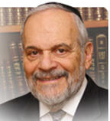

We are all aware of the famous comment of Rashi on the opening word of this week's Torah reading: that the departure of a pious man from the community leaves a void and a negative impression. This comment is in line with the pattern that we have seen from the beginning of the Book of Bereishit, i.e. that the Torah is more interested in the lives of individuals, than in the general pattern of societal history and culture.

It is the individual that makes the difference between good and evil, between eternity and the mundane, that evaporates so quickly. Therefore, the presence of a righteous person in a community is a precious asset that should not be ignored, minimized, or trivialized.

One righteous person represents an entire world and can be the difference between destruction and survival for a community. Throughout Jewish history, Jews have always attempted to live in the proximity of scholars and pious people. It is not only that they hope that some of their scholarship and piety would influence them, but it was also the realization that as long as there are pious, righteous people and scholars within the community, that community has a future and a purpose.

It was common throughout Jewish history when referring those scholars and pious people, the surname of the city where they lived was added so that the community in which they lived would be remembered and treasured, and because a righteous individual once lived there and was of influence.

In a world population of billions of people, we tend to believe that the individual does not count for much. This is an erroneous and certainly a secular view of life. It was the Soviet Union and Communism that saw people as being mere cogs in a great machine, the state, where everything had to be sacrificed in order to maintain that machine, even when it crushed millions of people and destroyed societies.

This is not so is the Jewish belief, for we are convinced that the individual has inestimable worth, power and influence. We believe that Heaven responds to, and, in fact, guides the life and deeds of individuals. No one is worthless or extraneous on the face of this planet, and it is wrong to think that individuals should be sacrificed for what is temporarily considered to be the greater general good.

That was the idea behind of the binding of Isaac by Abraham. In the world of that time, sacrificing human beings to appease the gods was an acceptable practice, believing then that the general population could somehow benefit.

When the angel tells Abraham to stay his hand and touch Isaac, and certainly not to kill him, the angel is also saying that one Isaac is worth an entire world. This idea must be reinforced repeatedly, for human society tends to forget or even ignore this concept. This is a powerful lesson for our time, and we should ponder these words of Rashi that introduce this week's Torah reading to us.

*Reprinted from this week’s website of rabbiwein.com*

*\*\*\*\*\*\*\*\*\*\*\*\*\*\*\*\*\*\*\*\*\*\*\*\*\*\*\*\*\*\*\*\*\*\*\*\*\*\*\*\*\*\*\*\*\*\*\*\*\*\*\*\*\*\*\*\*\*\*\*\*\*\*\*\*\*\**

*And he took one of the stones of the place, and put it under his head* (Gen. 28:11)

Why didn't Jacob choose something softer to use as a pillow?

Said he: "A stone of Eretz Yisrael is more precious than all the pillows and cushions I will ever use in the Diaspora." *(Otzar Chaim)*

*Ufaratzta (you shall break through; spread out) to the west and to the east, to the north and to the south* (Gen. 28:14)

At present, we must serve G-d in a manner of "ufaratzta," that is, without any restrictions or limitations. Thus we shall hasten the coming of Moshiach, of whom it is written in the Book of Micha, "The poretz (the one who breaks through, i.e., the one who clears all obstacles and barriers) is gone up before them."

*(Living With Moshiach)*

*Reprinted from the Parshat Vayeitzei 5756 edition of the L’Chaim Weekly, a publication of the Lubavitch Youth Organization.*

**The Significance of Jacob’s Sleeping on Mount Moriah**

**From the Talks of the Lubavitcher Rebbe**

**Rabbi Menachem Mendel Schneerson, Zt”l**

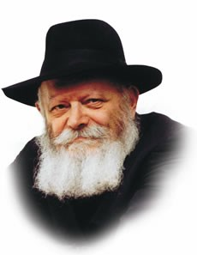

In the beginning of this week's Torah portion, Vayeitzei, Jacob sets out from Israel and journeys toward Charan. Reaching Mount Moriah, the place where the Holy Temple would one day stand, he decided to spend the night. "And he reached a certain place, and tarried there all night, because the sun had set."

Our Sages tell us that this was the first time in 14 years that Jacob had slept, having occupied his nights as well as his days studying Torah in the yeshiva of Shem and Eber.

**A Very Important Question**

This raises a very important question. Why, having not slept in such a long time, did Jacob choose the holiest site in the world to finally allow himself to sleep?

In order to understand, we need to examine the phenomenon of sleep and its spiritual significance.

Man's unique advantage over all other creatures is most openly expressed by his upright stature when he is awake. At such times, his head, the seat of the intellect, is clearly superior to his heart, from whence the emotions are derived. At the very bottom are his feet, symbolic of man's capability to perform concrete actions. However, when a person lies down to sleep, his head, heart and feet are all on the same horizontal level.

The upper body symbolizes man's spirituality; the lower part, his physical nature. When one is awake, the superior, spiritual component is dominant (and thus physically on a higher level); sleep, therefore, represents a great descent, for the spiritual and the physical are one the same level.

**Sleep Transcends the Limitations**

**Of the Physical World.**

Paradoxically, the phenomenon of sleep also expresses a much higher concept, one which transcends the limitations of the physical world. For from G-d's perspective, there is no difference at all between the spiritual and physical realms; both are identical when compared with Him.

Thus, when Jacob went to sleep on the holiest site on earth, the place where the light of the Infinite G-d illuminates most strongly, the limitations of the physical world (and indeed, the concept of "higher" and "lower" realms), were thus abnegated entirely.

This, then, is the inner meaning of Jacob's decision to sleep when he reached the site of the Holy Temple.

This same theme is also expressed in his dream of "a ladder set up on earth, and its head reached the heavens" -- linking and uniting both the physical and spiritual planes of existence.

**On the Way to Marry and**

**Establish the Jewish People**

The power to effect this connection was given to Jacob precisely during his journey to Charan, where he would marry and establish the Jewish people.

For in truth, establishing a dwelling place for G-d in this physical world is the essence of the mission of the Jewish people, a mission that will reach its ultimate fulfillment in the Messianic era, "when all flesh shall see that the mouth of G-d has spoken."

*Reprinted from the Parshat Vayeitzei 5756 edition of the L’Chaim Weekly, a publication of the Lubavitch Youth Organization. Adapted from Sefer HaSichot of the Rebbe, 5752, Vol. I*

**Parshas Vayeitzei**

**The Sensitivity of a Tzadik**

**By Rabbi Bentzion Shafier**

**Founder of TheSmuz.com**

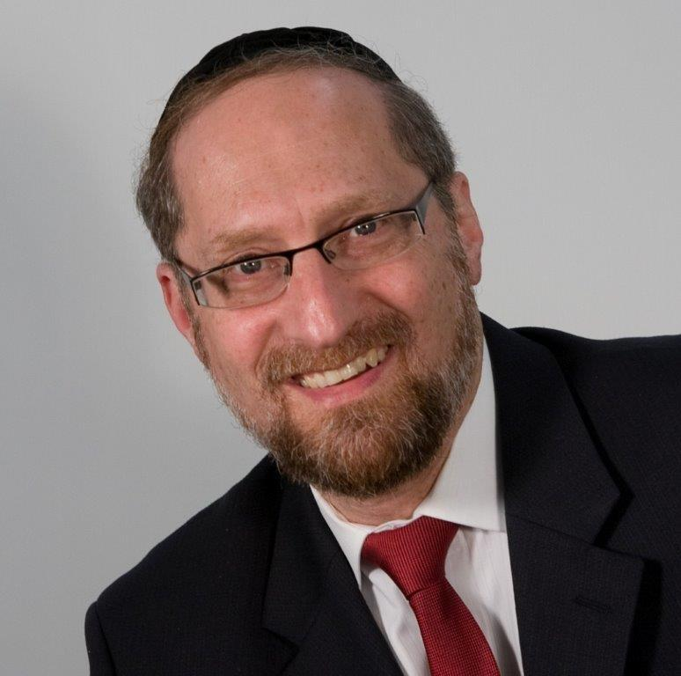

“*Then Yaakov kissed Rochel. and he raised his voice and wept.”* Bereishis 29: 11

When Yaakov met Rochel at the well, he experienced conflicting emotions. He felt tremendous joy at having finally met his bashert, yet he raised his voice and cried. Rashi explains that he cried because he came empty-handed. He said, “My father’s servant came with ten camels laden with gifts and finery, and I come with empty hands.”

Rashi goes on to explain to us why he didn’t bring a gift for Rochel. When Yaakov found out that Aysav was plotting to kill him, he fled from his father’s home. Aysav sent his son Alifaz to chase down Yaakov.

Alifaz was a Tzaddik, and when he approached Yaakov he said, “I can’t kill you because you are an innocent man. On the other hand, what will be with the command of my father?”

Yaakov said to him, “A poor man has the halachic status of a dead man. Take my money, and it will be considered as if you killed me, so on some level you will have fulfilled your father’s words.” As a result, Yaakov came to the well empty-handed. When it was time to propose to Rochel, he didn’t have the gifts that would be expected, and so, he raised his voice and cried.

This Rashi become difficult to understand when we focus on who these people were. The Avos may have walked the same planet as do you and I, but they lived in a very different orbit. Their every waking moment was occupied by thoughts of HASHEM. They lived and breathed to attain closeness to HASHEM. That was the focus of their lives and existence. It was the only thing that mattered to them.

**Did Rochel Really Care About Trinkets?**

For many years, Rochel knew that she was to marry Yaakov and be a matriarch of the Jewish people. You have to assume that when she finally met her bashert, she was overcome with joy. Here was the man that she had waited for! Here in front of her was this great Tzaddik, the man of her dreams, offering to marry her so she could take her place in destiny.

Her very life’s ambitions and desires were now coming to fulfillment. Could you envision any greater joy? At that moment, it is hard to imagine that she was concerned about glitter and trinkets. It is difficult to imagine that the lack of a little yellow, soft metal in the shape of a circle would bother her.

Yet Yaakov cried because he didn’t have a diamond ring to give her. The question is – why? All that Rochel really wanted was being delivered to her. If so, why did Yaakov cry?

It seems that the answer is that the lack of gifts may not have bothered Rochel much, but the bottom line was that it wasn’t respectful to her. When you come to your Kallah, you bring her a gift. That is the way that dignified people act. That is the way of the world, and it isn’t proper to come without a gift. On some level, it isn’t treating her with the kavod due to her, and that caused Yaakov pain – so much pain that he raised his voice and cried. On some level, it was a slight to the honor of Rochel. It wasn’t befitting her significance, so it moved him to tears.

**Every Person Hungers for Recognition**

This is a tremendous lesson to us because the people that we live amongst aren’t on the level of Rochel. To them, a slight to their honor is something that causes them real pain. People will go to great lengths to protect their reputation and dignity because these things are very important to them. And for that reason, we need to develop a real sensitivity to other people’s dignity and honor.

But this concept goes much further. The reality is that there are few people who get enough recognition and respect. We humans have many needs. We need food and drink, we need shelter and protection, and we need friends and companionship—most of our needs are met. The one need that that is almost never met is the need to be appreciated. It is something that we hunger for, something that is basic to our success and vitality. Yet there is no store in which it can be bought, no marketplace in which it can be acquired. And oftentimes, a person can go around with a deep hunger, not even realizing what is amiss.

One of the greatest acts of kindness that I can do for another person is to treat him with honor. If I find your currency and can acknowledge you in that vein, I can give you that which you deeply crave – and it costs me nothing.

The great dichotomy of human conduct is that I must run from my own kavod, yet run after yours. When it comes to my honor, I have to train myself that it is vain and frivolous, yet when it comes to yours, I have to do everything in my power to give you as much honor as I am able. A person who learns to find this balance becomes a popular and welcome companion, and is able to help others meet one of their deepest, unmet needs.

*Reprinted from this week’s website on TheShmuz.com This is an excerpt from the*[*Shmuz on the Parsha book*](https://theshmuz.com/product/shmuz-on-the-parsha-book/)*.*

**Rav Chaim Kanievsky Response To the Coming of Moshiach**

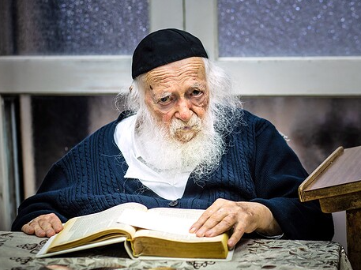

What did Rabbi Kanievsky Answer when Asked when the Messiah (Moshiach) would Come?

Rabbi Chaim Kanievsky receives numerous questions on a daily basis, both in matters of Halacha (Jewish Law) and Hashkafa (Jewish outlook and philosophy), as well as advice on various issues in daily life. This week, a question came from an unexpected source – the White House.  
 The newsletter called ‘Divrei Siach’ (compiled by Rabbi Chaim Kanievsky’s grandson) reports that two Jewish residents of the United States came to Rabbi Kanievsky's home in Bnei Brak, and presented themselves as associates of the American government, stressing that they are personal friends of President Donald Trump. They said the President asked them to convey his regards, and to say that he had heard a great deal about the Rabbi's influence among Jews around the world.  
 In reply to his question whether they want anything else, one of them answered: “The President wants to know when the Messiah will come.”  
 Rabbi Kanievsky smiled and answered: “And how are you preparing for the Messiah? Have you moved to the Land of Israel?  
 The Jew, who did not expect such an answer, could not hide his embarrassment, and answered “no”. The Rabbi continued: “Come and live here, and soon we will see the arrival of the Messiah, Amen.”

*Reprinted from the current website of HIdabroot.com*

******************************************************************

*Lo, the day is yet long; it is not the time to gather the cattle* (Gen. 29:7)

"The day is yet long" -- the great and powerful Day of the L-rd is approaching; "it is not the time to gather the cattle" -- there's no time to waste accumulating possessions in this temporal world, as every moment is precious. *(Ma'ayanot HaNetzach)*

*Reprinted from the Parshat Vayeitzei 5756 edition of the L’Chaim Weekly, a publication of the Lubavitch Youth Organization.*